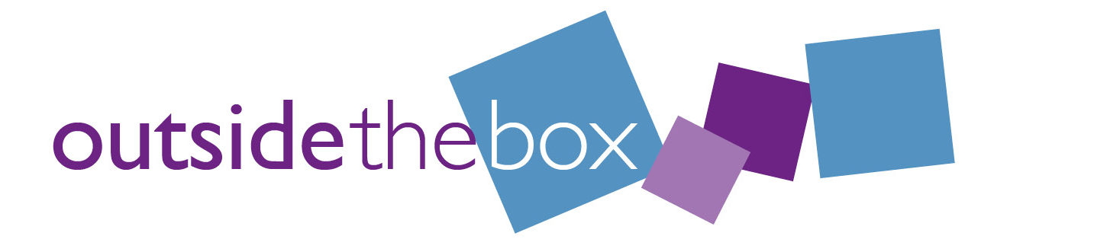
Project Worker
Application form

Personal Details

Name:

Address:

Email address:

Contact phone number:

Is there anything you would like to tell us that will support you at the interview, such as communication support or other adjustments?

Experience

Please let us know any experience you may have. This could include paid employment, volunteering, training, being part of community or professional groups, or from your own personal and family life.

What you bring to the role

It is not essential that you have experience in every task. Please share any relevant examples of your experience for the following tasks or how you would approach them.

Be a link between the Outside the Box Community Worker and the communities we are working alongside.
Build and maintain contacts with local people, organisations, and local businesses.

Support people to get involved in the project and their communities, this includes young people, families, and older people.
Support community events and workshops, ensuring they are accessible and inclusive.

Attend local networking meetings to represent the project and Outside the Box.

Update social media pages including Facebook and Twitter.

Support the local community to raise awareness of issues important to them.

Contribute to team meetings as required.

References:

Please list 2 people who can give a reference about you. Tell us their name, contact details and how they know you. They don’t need to be employers; it could be someone from a group you are involved with or another community member you have worked alongside.

We will not contact any referees until after the interview.

Referee 1:

Referee 2:

Thank you for applying for this post. We will contact you to let you know the outcome of your application.

Please send this completed form to:
admin@otbds.org by noon Friday 15th April 2022

