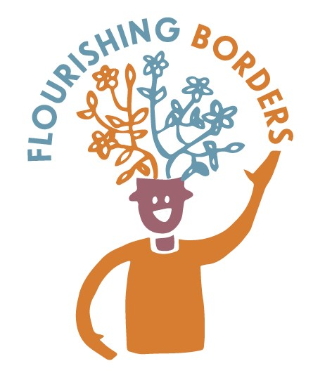
Happiness Habits Cafés
Whim Hall Care Home

Where: Whim Hall Care Home, Whim Estate, Lamancha, West Linton EH46 7BD
When: 8th December 2016, 2.30-4.30pm

Background
Happiness Habits Cafes have been developed by Outside the Box. The sessions in Borders are part of the Flourishing Borders project, which aims to increase awareness among older people about how they can look after their mental health and wellbeing.

Ian Stewart, a member of the SBC Community Capacity Building Team, had been liaising with the Matron in charge of Whim Hall talking about doing some work with residents and getting them involved in community activities. Some preliminary scoping work had explored bringing residents by minibus to the Lamancha Hub, for a visit when they would take part in a Happiness Habits café, have lunch, and try an activity like “New Age Kurling”. Unfortunately, the Lamancha Hub was unable to go ahead with the day, and it was cancelled.
The Café
We decide to hold a Happiness Habits café at the Whim Hall and Ian Stewart liaised with Isobel Roast the Activities Coordinator as the Matron had since left her job. We set up a date for 8th December 2016, and Christine and Lindsey from Outside the Box plus Ian from the Community Capacity Building Team travelled to Whim.
Isobel who coordinates activities at the home, and her staff team supported 14 residents to attend the café session. 3 of the support staff stayed for the café and took part in table discussions which was a real help as they knew the residents well and could help with communication. Some of the residents attending the café are living with dementia and other long term conditions.

We had teas, coffees and festive treats for the café and the tables were laid
with white paper tablecloths to be written on. Due to the logistics of getting residents to the café, and the staff time involved, we did not manage to complete the before and after evaluation.

The café followed the approach of having table questions to prompt discussion about wellbeing and mental health. The following questions were used:
- What are your top tips for coping with life?
- We all have times when we feel down – what helps you at those times?
- Keeping active is a great way to boost your wellbeing – what do you like to do to keep active? (with picture prompts)
The staff sitting at the tables then facilitated and encouraged discussion around the questions that were on each table. We all have times when we feel down – what helps at those times? and What are your top tips for coping with life? Those present at the session took part in the conversations, although some residents needed some help with communication from care staff. There was a tendency from some people to talk about the past and life in younger years, rather than keeping focussed on the here and now.

The main things that were identified by the residents that help when they feel down are:
Attitude/mood – You’ve got to smile, good food makes you happy, friends help, making models takes your mind off your pain, the main thing for me is if my health is all right, go out for a walk – you feel relaxed, I put on a scarf and feel nice!

Sense of purpose – help people, go for a walk and talk to people, when people have died, it is difficult: I try to keep busy.

Hobbies/activities – read novels and crime books, read technical books, SBD travelling library is great, walking around the lovely grounds here, grow plants, visits – to Ratho Canal Centre, watch Weir’s Way on TV, ballroom dancing would be lovely! Music – to get up and dance to. I like to imagine something and then paint it – like the hills,

Connection to others – grandchildren visiting, my family and other visitors, outings, play online and get connected to people, listen to the news of the outside world, get away to visit family sometimes.

What are your top tips for coping with life?
- It is important to still see lots of people, but have some time on your own.
- Sit and discuss things with people, argue a bit but have fun too.
- Get out and walk in the grounds outside.
- Spend time being thankful.
- Know yourself – what you like.

December 2016 Follow up:
Isobel the Activities Coordinator was pleased with the café discussions and she felt that people had joined in and enjoyed the conversations. She is new to her post, and wanted to build on the things that the people had commented on. We were all struck by how much people talked about dancing – old time ballroom dancing, and how it had been something that they really enjoyed. We spoke about trying to organise a taster dancing session, and contacted a local ballroom instructor. We have not to date heard back from this instructor, and have struggled to find other people to help.
Outside the Box has run a previous project organising Belly Dancing in Care Homes as part of their “we’re Here Too!” project which values those who have lived longer than the rest of us – tackling ageism and allowing older people to flourish. http://otbds.org/?s=belly+dancing
Isobel was not sure whether the residents would want to try belly dancing but is currently planning her activities programme so this may be a follow-on activity that we offer.

Contacts for Happiness Habits Cafes:
Christine Ryder, Communications & Resource Worker with Outside the Box. christine@otbds.org. Mobile: 07921 265515
Lindsey Gray, Associate Worker with Outside the Box
lindsey@spinningfish.net Mobile: 07865 081369

Outside the Box
Unit F10, 150 Brand Street, Glasgow, G51 1DH
Office: 0141 419 0451
Website: http://otbds.org

The Flourishing Borders project is funded by:

