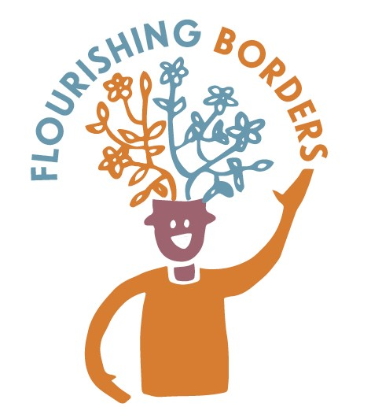
Happiness Habits Cafés
Netherurd

Where: Netherurd Memorial Hall, West Linton EH46 7AJ
When: 20th January 2017, 2-4pm

Background
Happiness Habits Cafes have been developed by Outside the Box. The sessions in Borders are part of the Flourishing Borders project, which aims to increase awareness among older people about how they can look after their mental health and wellbeing.

Ian Stewart from the Community Capacity Building Team at Scottish Borders Council had been having some conversations with Margaret Anderson and Peggy Wills who are committee members for the Netherurd Memorial Hall. This hall is a locally owned venue which is run as a charity for the benefit of the community around the area. The local area of West Linton has changed over the years, and now has many residents who live there but commute daily to Glasgow or Edinburgh. This has changed the pattern of community life and people feel less connected by things like local halls and the events that go on there. Margaret and Peggy met with Ian Steward and Lindsey Gray in December 2016, and we talked about having a Happiness Habits Café with a lunch in January and advertising it around local towns and villages. The area is very rural with many small settlements and town. Margaret and Peggy want to increase the use of the hall and increase local connections. Both are members of the Rural Institute and have lived in the area for many years so are well connected. They offer a toddlers group at the Hall once a week, so it was hoped that the café might be attended by a mix of ages.

The Café
We decided to have a café with stovies for lunch, which would be made by the Chef at the local Girl Guiding Centre at Netherurd House. Posters were produced by Scottish Borders Council and were distributed around the area. Local newsletters were used to publicise the event. We offered community transport for the event. It was suggested by Ian Stewart that he would bring the New Age Kurling set, and people could have a go at a game of Kurling after the lunch and discussions.

On the day, Margaret and Peggy from the Hall Committee set up the hall and lit the fire which made things really welcoming and warm. The stovies were delivered, and Margaret and Peggy had also organised home baking and teas/coffees.
A steady flow of people started arriving. Although community transport had not been requested, some people offered lifts to others through a local lift scheme.

There was a good turnout to the café, with 12 people attending plus Christine and Lindsey from Outside the Box. One of the young mums from the group came along with her primary school aged son who thoroughly enjoyed the event and joined in with the kurling.
Unfortunately, due to illness, Ian Steward was not able to come on the day. He did however organise a kurling set for us to use, which was lent to us by the Newlands Centre near West Linton.

The café followed the approach of having table questions to prompt discussion about wellbeing and mental health. The following questions were used:
- What are your top tips for coping with life?
- We all have times when we feel down – what helps you at those times?
- Keeping active is a great way to boost your wellbeing – what do you like to do to keep active? (with picture prompts)
- Staying in touch with people is good for our wellbeing – what’s on and what’s missing in the local area?
A short introduction to the café was given by the Lindsey, and then people were served tea and coffee. Those sitting at the table were encouraged to fill in the sheet “How I feel before the café” (repeated at the end of the café, “How I feel after the café” to try and assess the impact of having these conversations on people’s mood. You will find out a little later if the café had an impact!

Lindsey and Christine sat at the tables and encouraged discussion around the questions that were on each table. We all have times when we feel down – what helps at those times? and What are your top tips for coping with life? There was some reticence from those present at the start about talking about their mental health/wellbeing. One lady expressed with some feeling that “it is terribly difficult to talk about this, as we are not used to sharing this sort of thing”

The things that were identified at the Netherurd cafe that help when we feel down are:

Attitude/mood Gardening can be good but can be depressing – my thoughts wander. Great to watch the kids out sledging. Music – Scottish music that you don’t get on the tv or radio, classic fm,

Sense of purpose I get involved in community things – Rural, Mum’s & toddlers, Netherurd Hall (I get enjoyment for the sake of others) guild, because it helps the community – used to do cubs (got the silver acorn award). Being part of something, going to church.

Hobbies/activities Going for a walk, watch the birds in the garden,
Exercise, grow veg so I can make soup at any point.

Connection to others Companionship through doing things in the church. Help with young families – I get the gossip. I don’t phone my sister – come away demoralised. Someone coming in to see you. Using the mobile library which comes ever 3 weeks. Pick up phone/ipad and connect with big family even if they are on the other side of the world.

What are your top tips for coping with life?
- Keep active but don’t do so much that you get tired
- Volunteering so you get out of the house
- Get out of the bed and get on with the day
- Keep busy and do some cleaning

Other coping strategies that might not be entirely positive, but which were named included: Gin, shouting at the telly, blaming the government, shouting at the dog, sulk, cry, stomp, just get on with it, don’t talk about it.

There was a lot of discussion about the difficulty of talking about mental health and a few questions about whether it was a good thing to talk about it. A few people felt that the younger generation focusses too much on talking about feelings. The group who came to Netherurd felt that:

Maybe we’ve learned to cope due to the hard lives we’ve lived
This generation just got on with it – all this talking doesn’t help

I cope by telling myself “I’m fine” and letting things slide over me.ne – I let things ‘slide over my head’ fine – I let things ‘slide over my head’

How people felt before and after, here’s a selection of what they said!

Anxious, sad, cross, tired Lonely, fun, friendly, fit, confident
Bored, dull, fed up cheerful, OK

Pressurised, OK, tired Relaxed, listened to, encouraged

Lonely, anxious, lucky, fit, Happy, friendly, good about myself, Fed up cheerful

Happy, supported, friendly Happy, relaxed, supported, listened to, friendly, fun, cheerful, encouraged

Anxious Happy, relaxed, supported, friendly, cheerful

After the lunch and discussion, we played a game of “New Age Kurling” which was very much enjoyed by all. People enjoyed the friendly competition, and the long and narrow hall made an excellent space for the game.

What next?

Following a discussion, the people present asked if there could be a follow up evening with Kurling and home baking later in March, and that the whole community could be invited. This would be an event that could be used to promote the hall and its potential use by the community. It was felt that a Kurling kit might be something the Memorial Hall Committee might try to buy, to run community kurling evenings, and the evening in March, which is booked for the evening of the 16th, will be a trial session to see how the community enjoys the kurling and home baking event.

Contacts for Happiness Habits Cafes:
Christine Ryder, Communications & Resource Worker with Outside the Box. christine@otbds.org. Mobile: 07921 265515
Lindsey Gray, Associate Worker with Outside the Box
lindsey@spinningfish.net Mobile: 07865 081369

Outside the Box
Unit F10, 150 Brand Street, Glasgow, G51 1DH
Office: 0141 419 0451
Website: http://otbds.org

