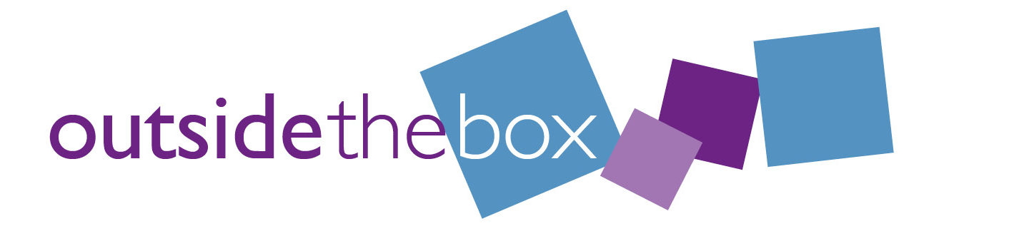

Project Worker

Application form

Personal Details

Name:

Address:

Email address:

Contact phone number:

Is there anything we need to know that will help you at the informal interview, such as communication support or other adjustments?

Experience

Please let us know any experience you may have, this could include paid employment, volunteering, training, being part of community or professional groups, or from your own personal and family life.

What you bring to the role

It is not essential that you have experience in every task, please share any relevant examples of your experience for the following tasks:

A knowledge and understanding of the issues facing people, groups & businesses in the village?

Helping out in the village i.e. school/village fair, setting up group, part of covid response, arranging lift shares with others to get to groups/activities etc?

Nudging and encouraging people to get involved in something?

Using digital technology and connecting with people digitally i.e. using social media, zoom or similar platform to connect with others and other digital skills you may have?

Feeding in ideas you have had or from on behalf of others to ensure your/their voices are heard?

Working as part of a team and managing your time and resources to ensure everything happens when it should?

Helping to organise small events or setting up groups?

Anything else you think is relevant?

References:

Please list 2 people who can give a reference about you. Tell us their name, contact details and how they know you, it doesn’t need to be an employer it could be someone from a group you are involved with or another community member you have helped.

We will not contact any referees until after the informal interview.

Referee 1:

Referee 2:

Thank you for applying for this post.

Please send this form to christine@otbds.org by 12 noon on Monday 21st September 2020.

