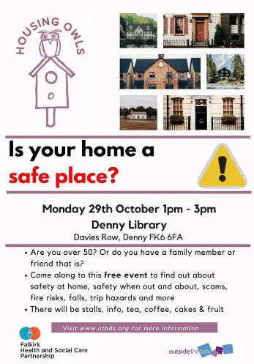
Be Safe at Home with Housing Owls
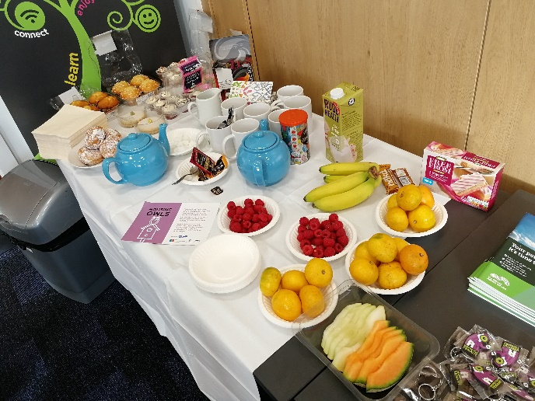
On the 29th of October 2018 Outside the Box held a Home Safety awareness event for the Housing Owls project. Housing Owls is a project delivered jointly by Outside the Box with Grangemouth Citizens Advice Bureau, funded by Falkirk Health and Social Care Partnership. The event was an opportunity for older people in the area to come along and hear from a range of different organisations about how they can stay safe at home.
We arranged to hold the event at Denny Library, a place that we know is well-known in the local community. Denny Library has great facilities, is easy to get to by public transport and is accessible for wheelchair users.
To ensure that as many people as possible knew about the event, and came along, we produced a poster promoting the event and shared it in different places like the library, local community groups and organisations. We also advertised it in the Falkirk Herald newspaper.
We got in touch with different organisations that focus on home safety and invited them to come along to share information. We told organisations that they could have a stall on the day and encouraged them to bring along information to share with older people.
On the day we welcomed people into the space and ensured they felt comfortable. We offered free teas, coffees and cake along with a variety of fruit and encouraged people to help themselves and take their time exploring the space and all the stalls present.
Different groups and organisations set up stalls with information and chatted with people about any issues they wanted information on. People were also given resources to take home with them to enable them to get solutions for their problems and to also share with any friends or relatives that needed the same information. Organisations such as Police Scotland also did demonstrations throughout the day to help older people learn how to keep themselves safe.
We also had a stall for Housing Owls where we shared information on the project and directed people to where they would be able to get the help they need. In this way we were able to promote the project itself and speak to people about the Housing Owls visiting any groups they attended to run an information session.

Examples of what we heard
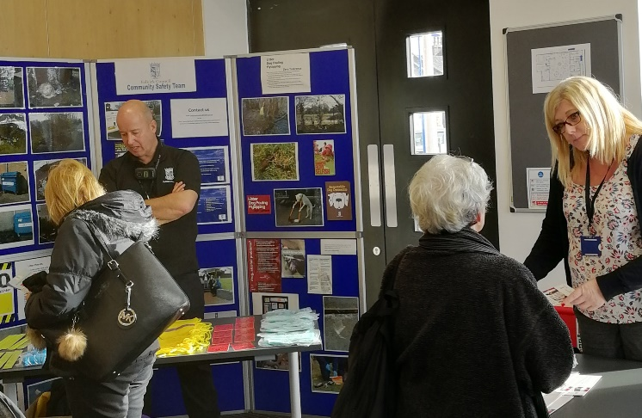
One 88 year old lady came with her daughter, as she had been a target of attempted burglaries on a number of occasions in the recent past. The daughter was very concerned for her mother, who lived alone. They really appreciated being able to speak with the Police and the Community Safety Team about their concerns.
An elderly lady has been receiving a large numbers of nuisance calls and was very stressed about it. She felt the only option left to her was to unplug the phone, but she didn’t want to do that. Trading Standards were able to advise her on different ways of stopping the calls getting through, such as a call blocking unit and phones with additional security measures installed.
A lady representing the Nifty Fifties group in Banknock came in to get general information for the group. Contrary to the name, the group has many members over the age of 70 and safety is a big concern for many of the 25 plus members. The lady was very impressed with he event and took away lots of materials to share with the group.
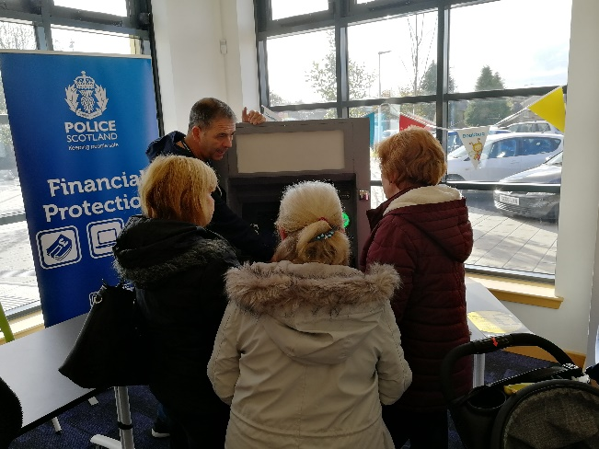
How it went
The day was well attended, with dozens of people coming along. At the event we asked for feedback to help us improve the way we run these information events. We were pleased that everyone present reported that they found the day to be ‘very useful’ with two thirds of people indicating on the feedback sheet that they had learnt something new about safety.
We also got feedback from some of the organisations that had stalls about how the event went for them:
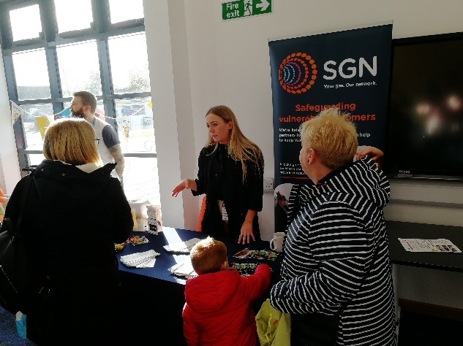
SGN:
“We’ve been here today to provide information on our locking cooker valve, which is fit free of charge. We usually fit these for people who have dementia, Alzheimer’s or people with autism that might accidentally leave the gas cooker on as there is obviously a risk of gas fires or carbon monoxide poisoning if left unattended. We’ve also shared our gas safety booklets letting people know what to do, and what not to do, if they smell gas. People have been really interested and have taken away leaflets and we’ve made some good contacts for promoting this further in the local community.”
Trading standards:
“We’ve been talking to people about scams and call blocking units. We’ve been hearing about people’s experiences of scams. People are very interested. People have taken the leaflets away with them and we have given everyone advice. One lady is going to come back for a call blocking unit for her mum as she thinks she will benefit from it.”
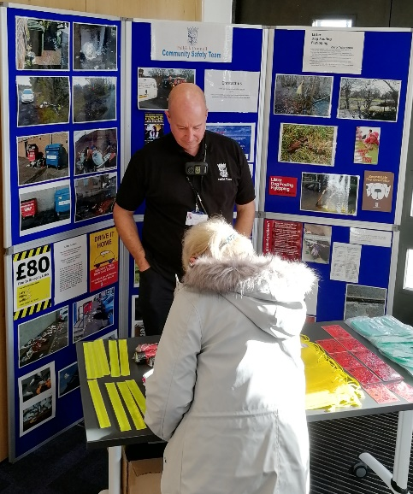
Police Scotland:
“People have been asking about financial harm, card cloning, online scams via computers and phone scams. People have been generally most interested in information on card cloning, knowing what to look for and how often to check our banking and accounts. In terms of phone scams, we shared what kind of information they shouldn’t give out and, in relation to computer scams, what to do with unsolicited emails and to ensure they don’t click onto any hyperlinks and so on.”
Community Safety Team:
“People have been asking about fly tipping in the area, what we are doing to combat that. We have new cameras, and mobile cameras so that has been helping a lot. Also, for litter, we have been having a conversation with a local primary school (primary 6 and primary 7). We do walkabouts at lunchtime to count all the litter from the school children along with the school police officer. Also today we’ve been having conversations about youngsters walking about and older people’s safety. People said it’s been helpful and really good and they took away materials.”

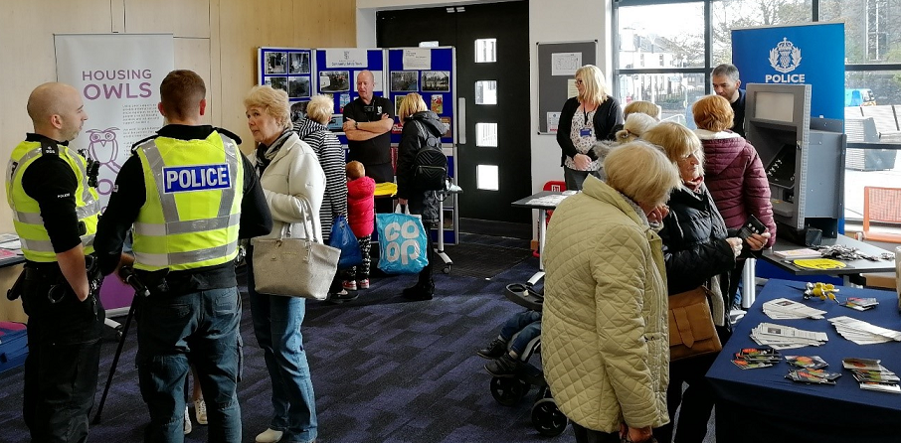

This report was produced by Outside the Box Development Support. For any more information please contact Ania Sandland, Community Development Adviser by email: ania@otbds.org or phone: 07514 905 945
For general information about Outside the Box please contact our office
Tel. 0141 419 0451
Email: admin@otbds.org
Web: www.otbds.org

