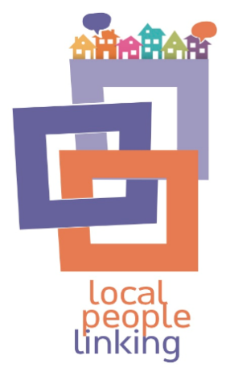
Local People Linking by Outside the Box is a project to help link older people with the local activities and supports they enjoy. We’re here to help bring groups together to learn about each other and create new opportunities in the community.
Learning about rights as part of Local People Linking is a FREE training opportunity open to anyone who is interested in learning more about human rights and how they play a part in community supports and activities for older people.
Who is it for? All are welcome, including older people, families, friends, community groups as well as workers from any sector working with older people.
What’s involved? We will come to you to run a free taster session. If you are interested in more sessions we can deliver at a time and place suitable to you.
Get in touch To book a place or if you have any questions please contact:
Jill Keegan - jill.k@otbds.org
07841015949

