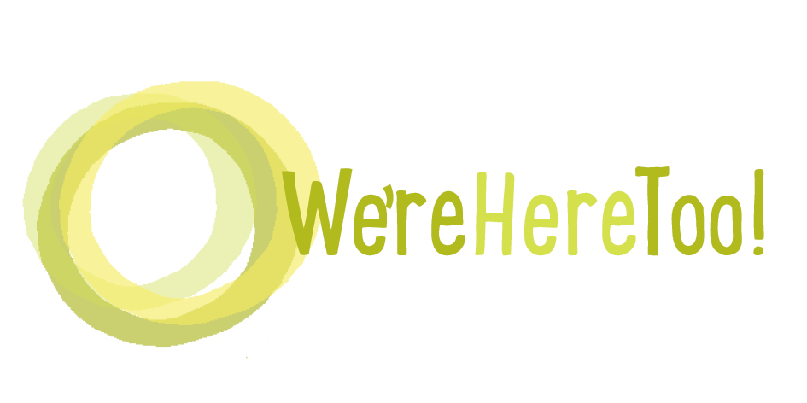
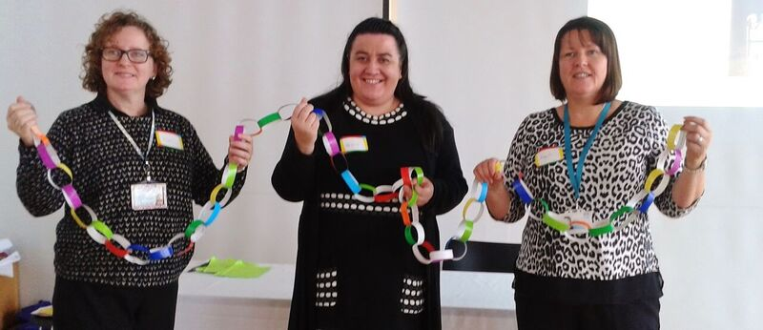
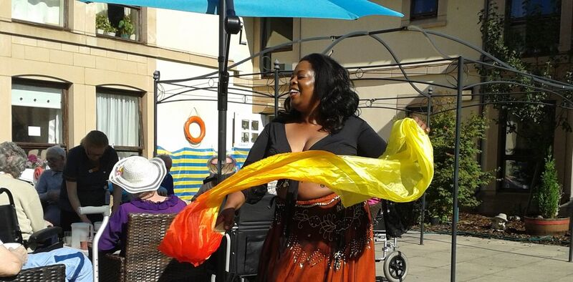
We’re Here Too

15th November
Forth Valley Sensory Centre,
Falkirk
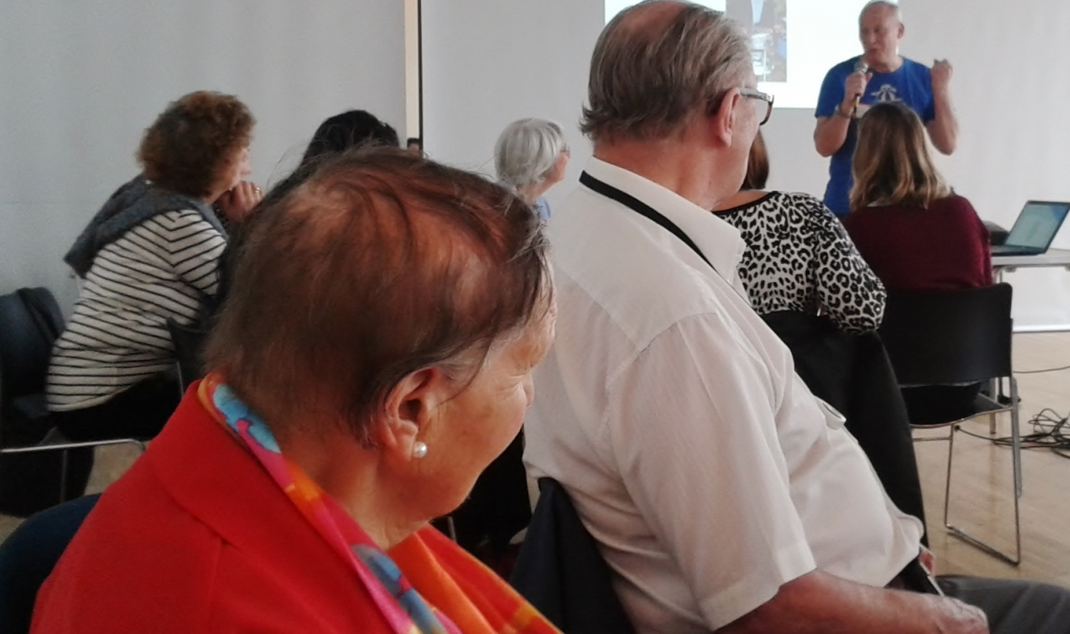
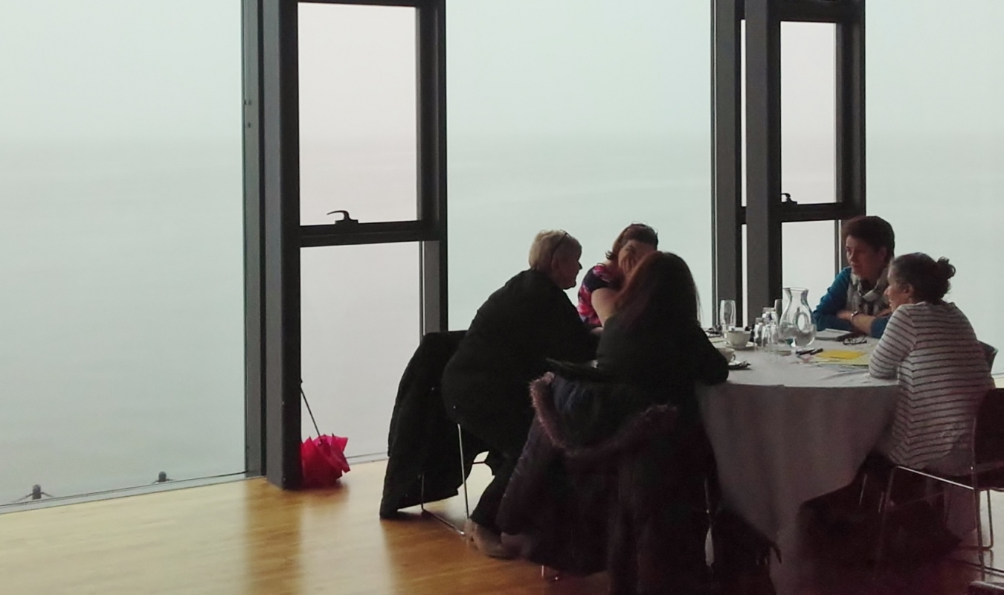
Information on public transport is our website: http://otbds.org/projects/were-here-too/ and on the Sensory Centre website http://fvsensory.jimbyrne.co.uk/
10 – 10.30: Coffee and registration

Morning session

Welcome and introduction

Support that is right for each person
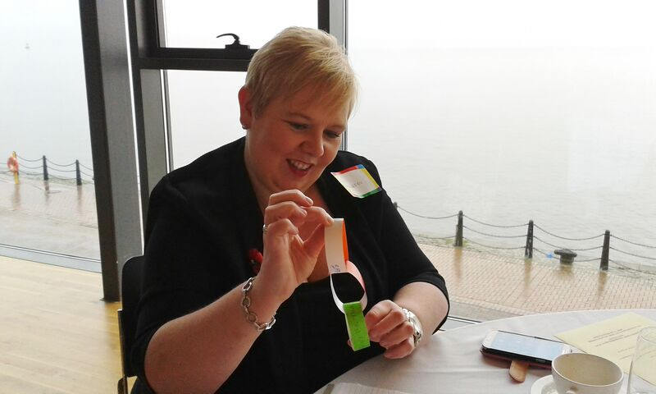
- Examples of support for minority ethnic people and their families
- Inspection Volunteers – bringing lived experience into Care Inspectorate inspections

Being active - walks, belly dancing and more
- Work by Care Inspectorate to share what works
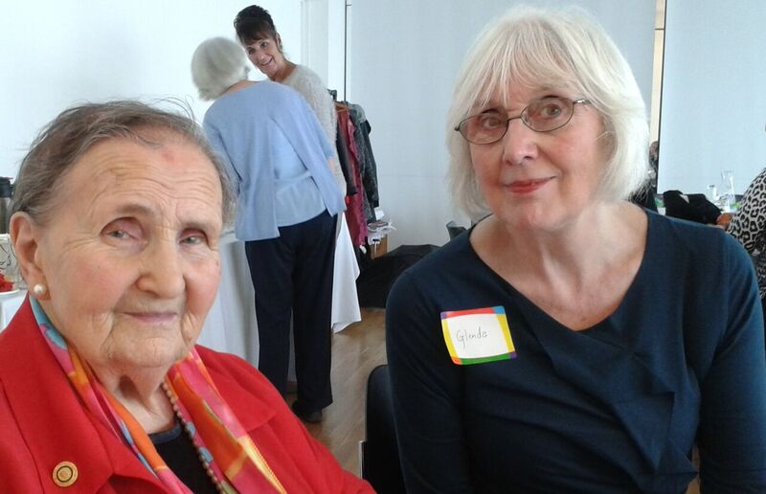
- Practical examples of how people are enabling people who need extra support to be more active

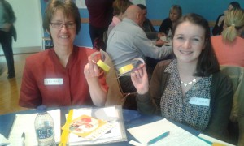
Discussion: What helps people who need extra support be part of their communities?

Lunch

Demonstration/practice of belly dancing for people who want to do this.
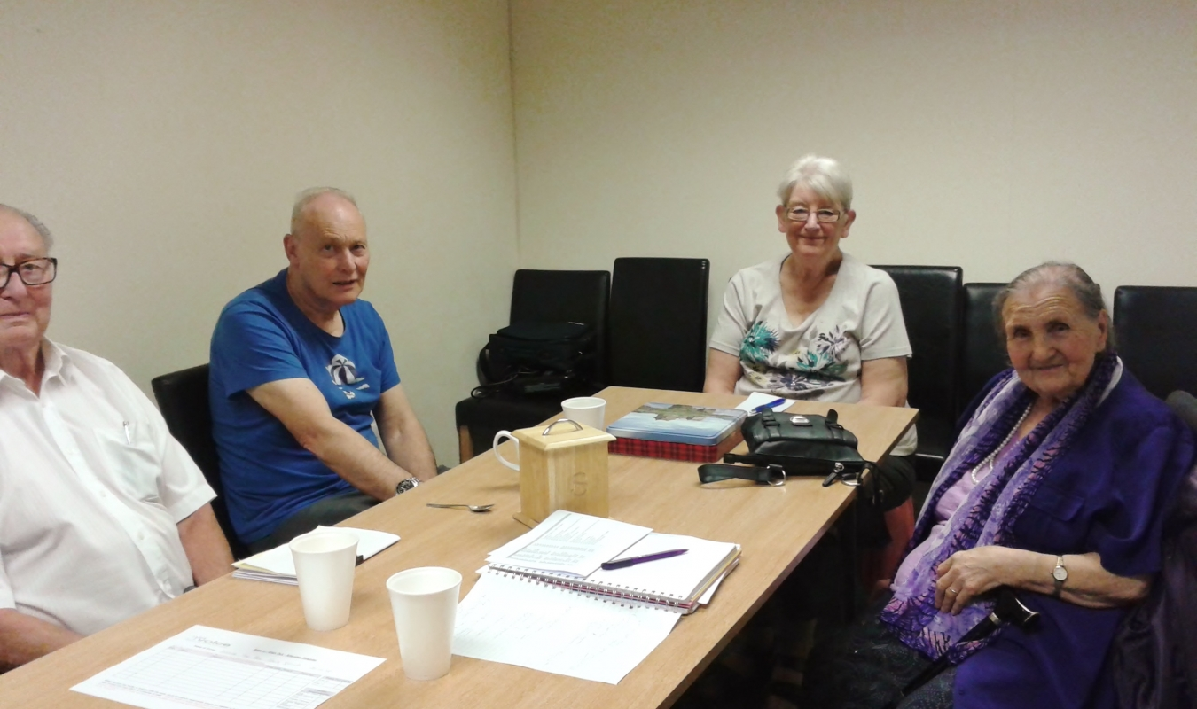

Afternoon session

New approaches to community-based support
- Examples of micro enterprises and what makes them work well

Discussion: What supports older people’s well-being?
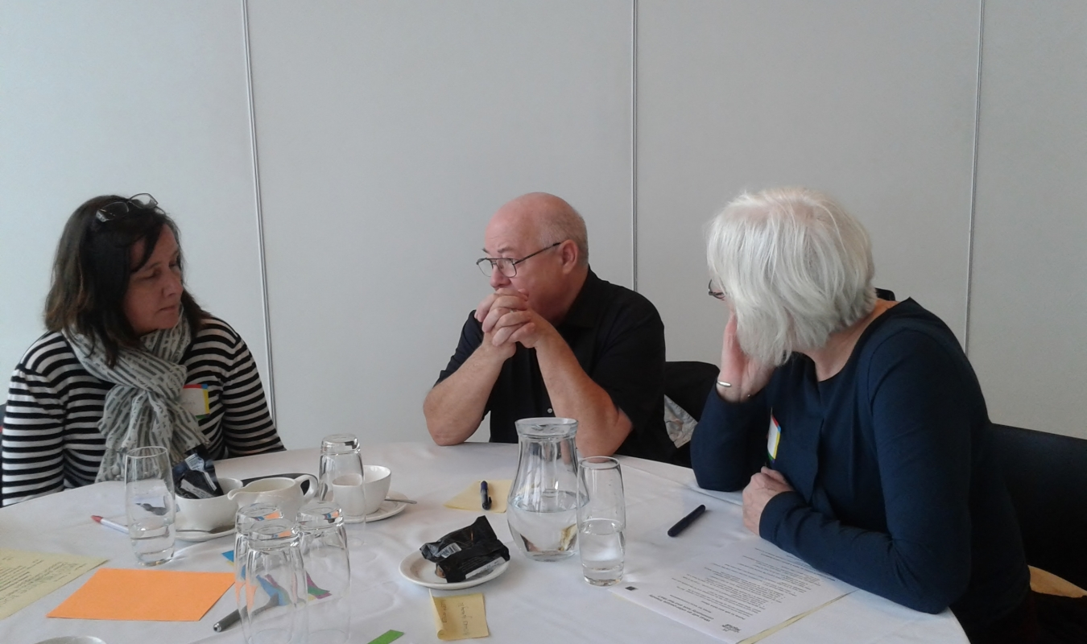
Taking things forward

3.30: Home
