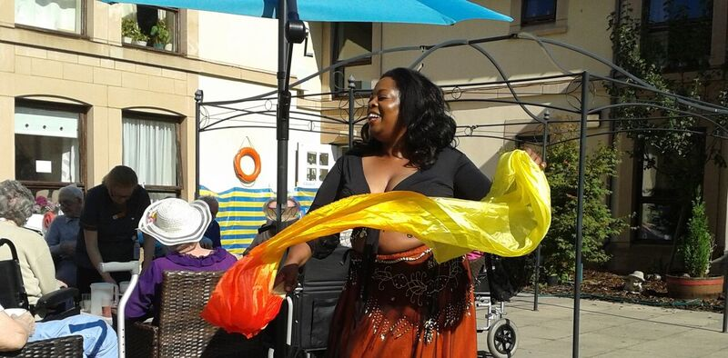
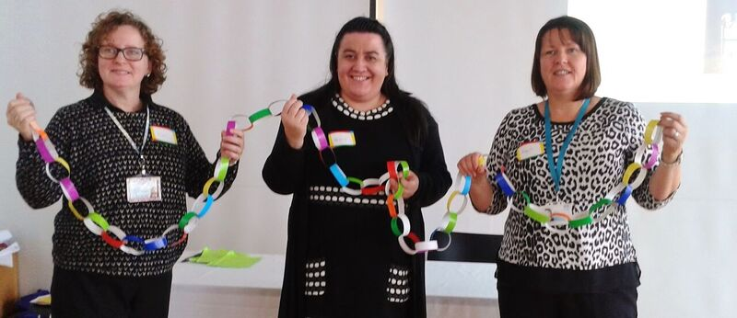
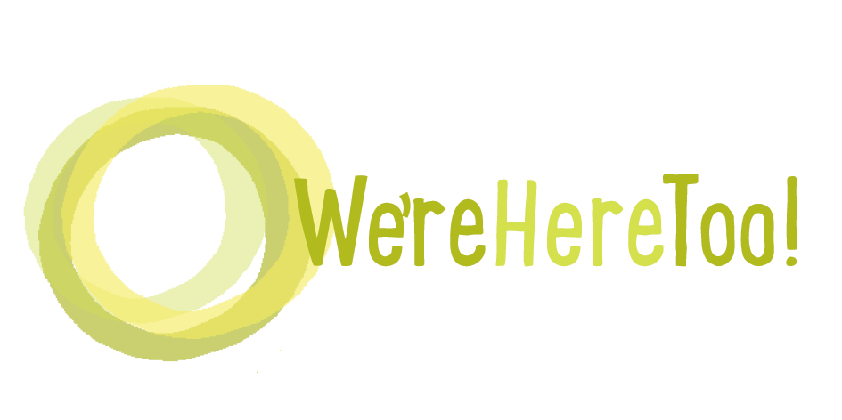
We’re Here Too
24th October
Eastwood House,
Eastwood Toll,
East Renfrewshire

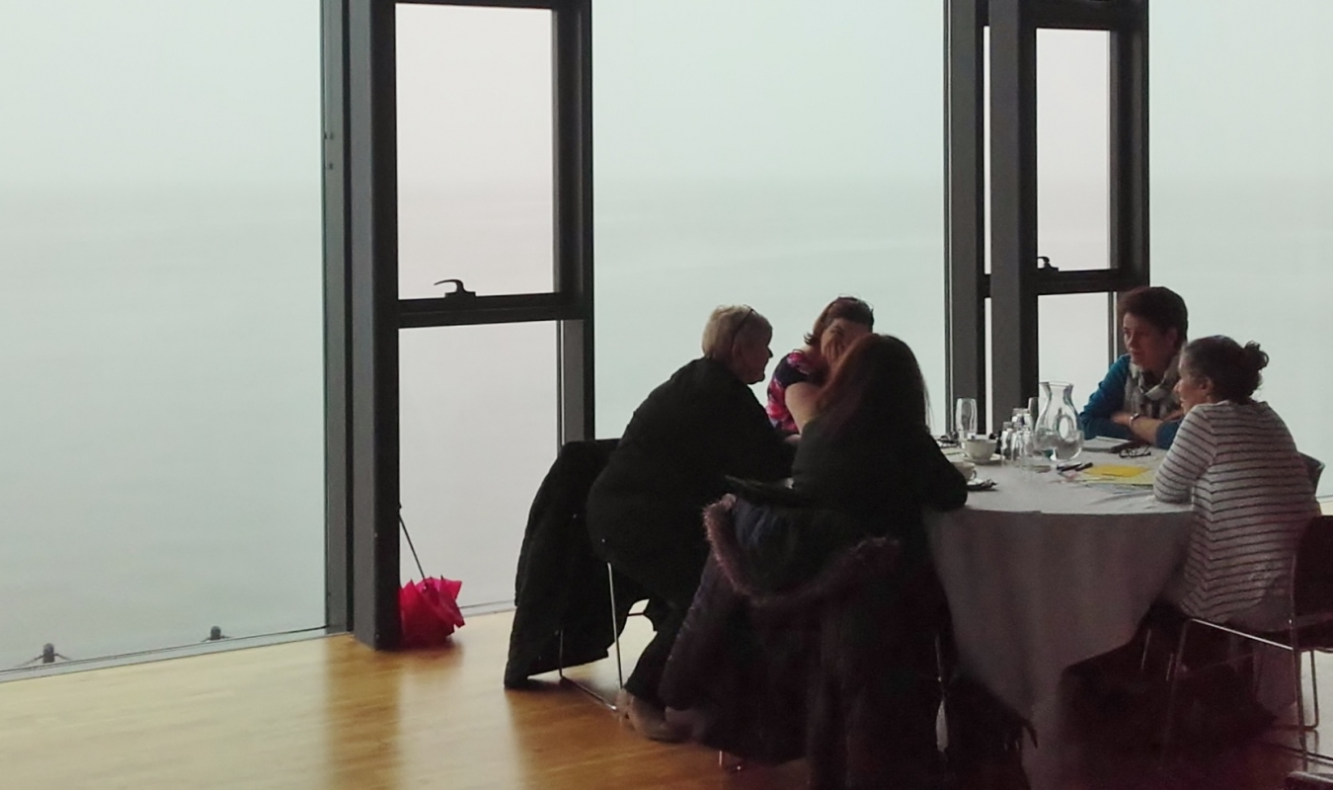
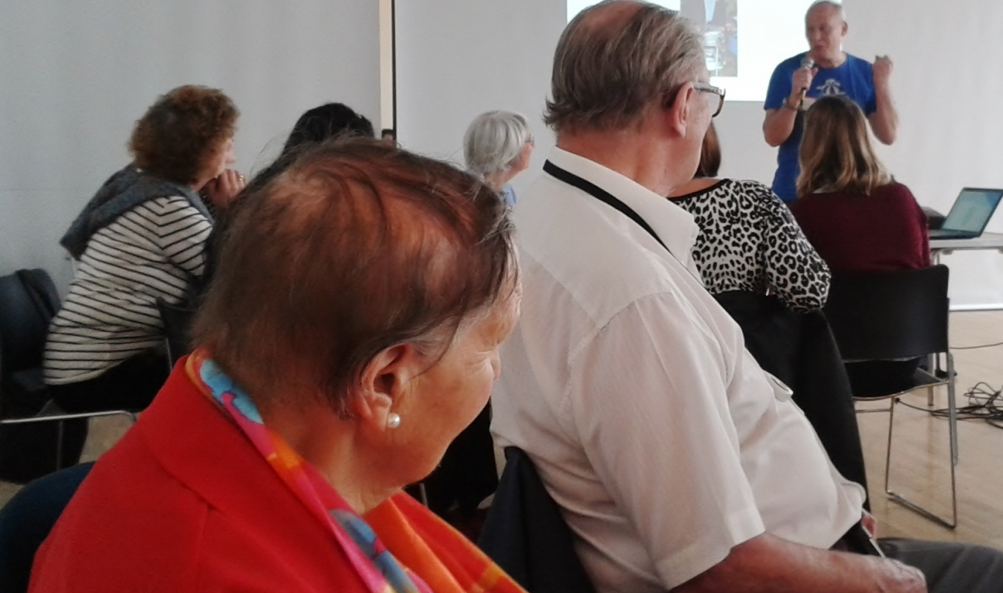
Information on public transport is on our website: http://otbds.org/projects/were-here-too/

10 – 10.30: Coffee and registration

Morning session

Welcome and introduction

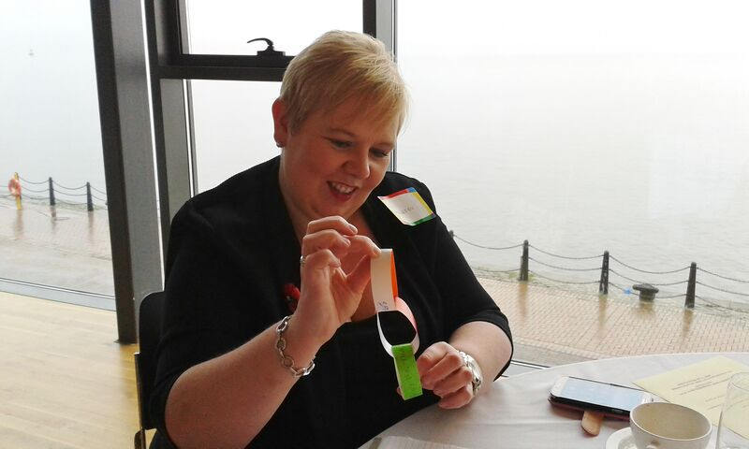
People living in care homes being part of their communities

- Presentations on what some care homes are doing to make links and invite community activities in
- Example of community activities welcoming people who live in local care homes

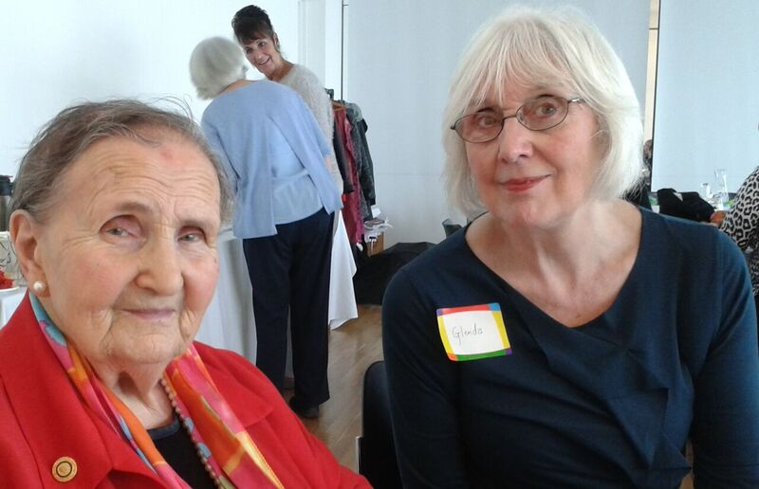
Discussion: What helps people who need extra support be part of their communities?

Being active - walks, belly dancing and more

Lunch

Demonstration/practice of belly dancing for people who want to do this.
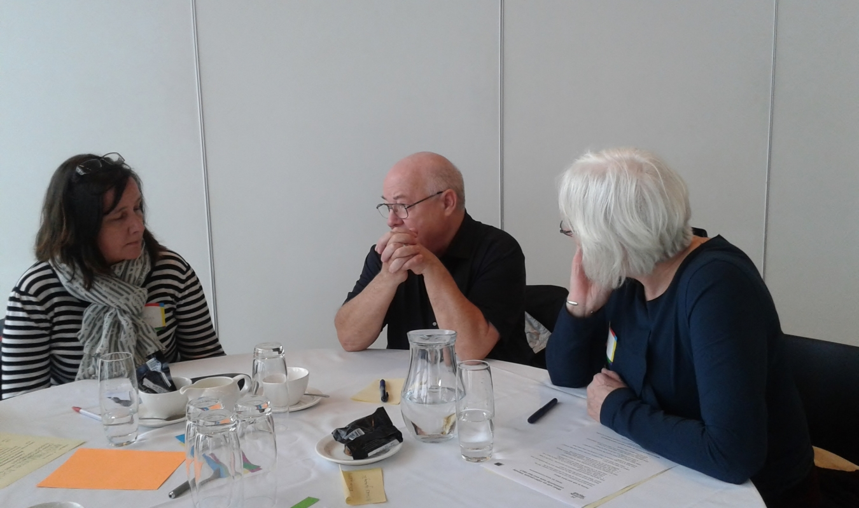
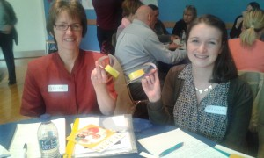

Afternoon session

Support that is right for each person
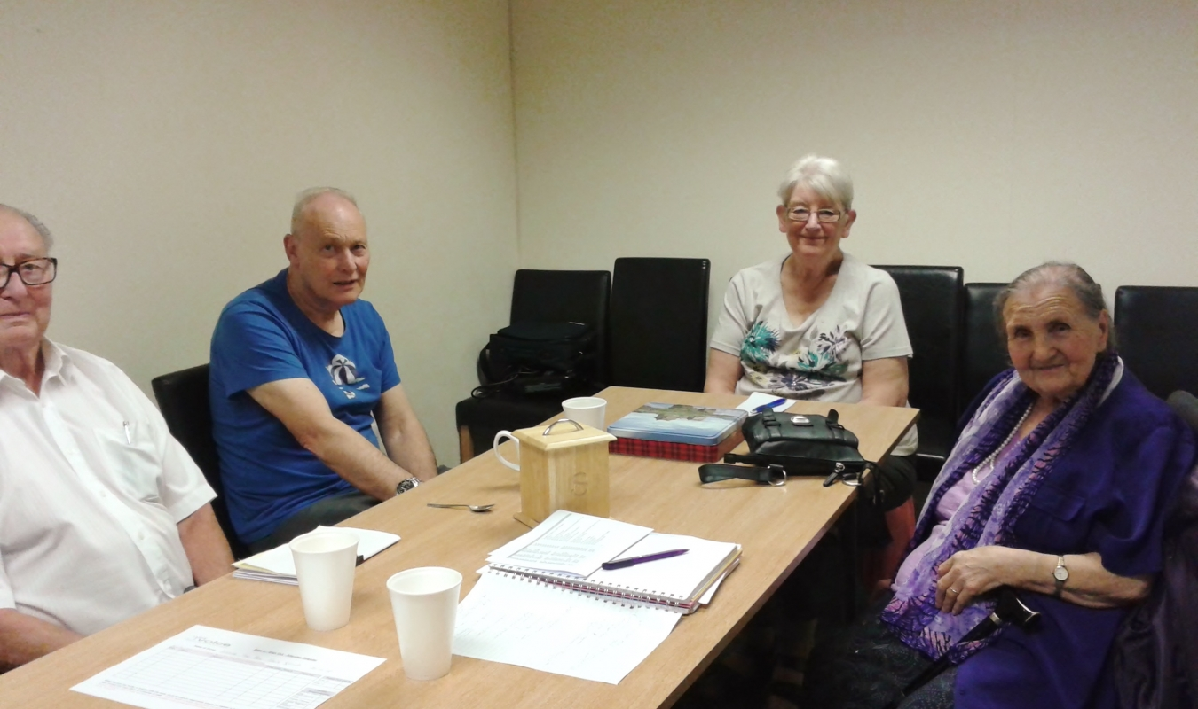
- Examples of support for minority ethnic people and their families
- Inspection Volunteers – bringing lived experience into Care Inspectorate inspections

Discussion: What supports older people’s well-being?

Taking things forward

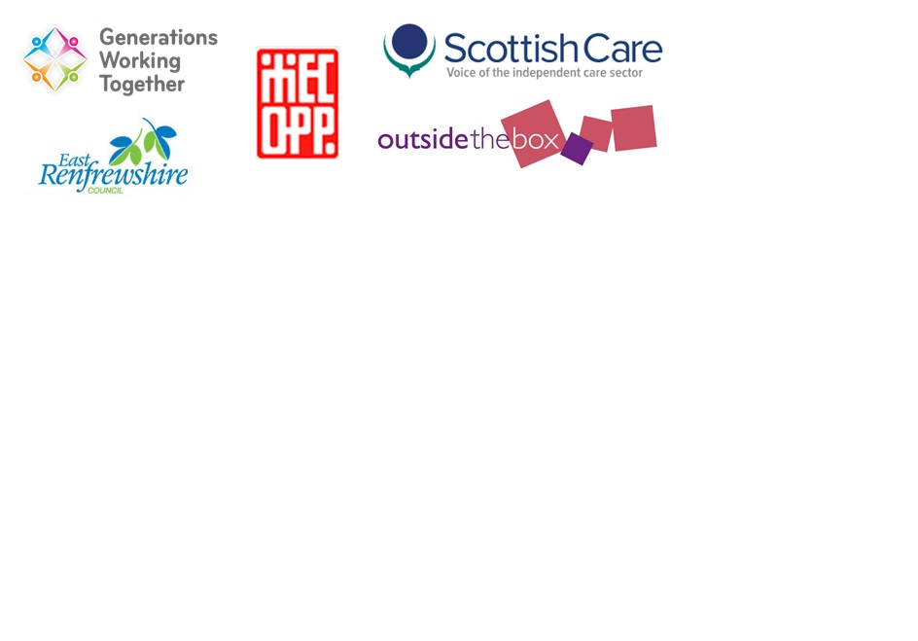
3.30: Home

