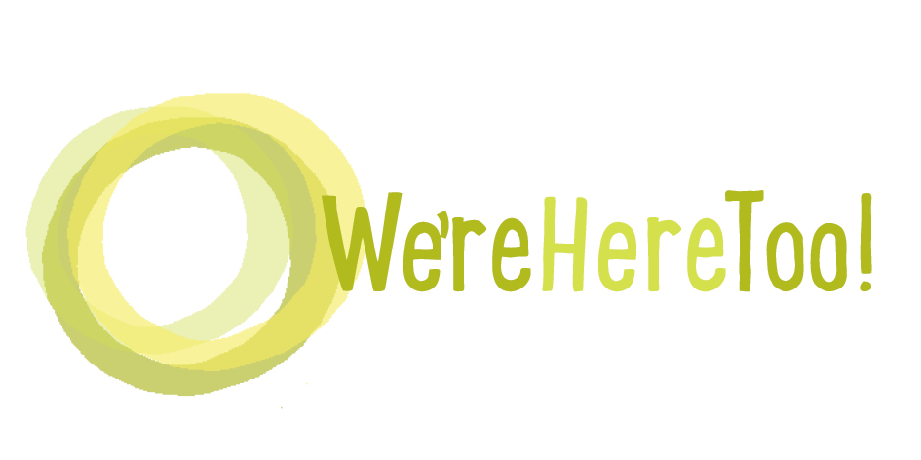
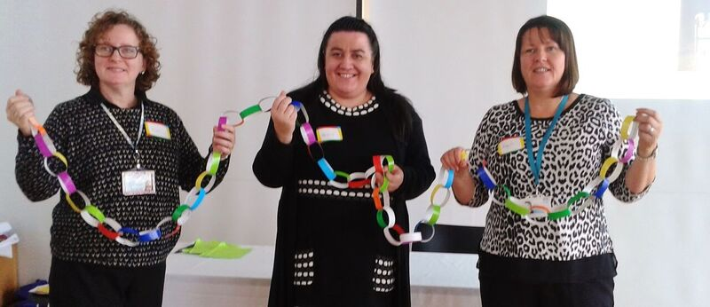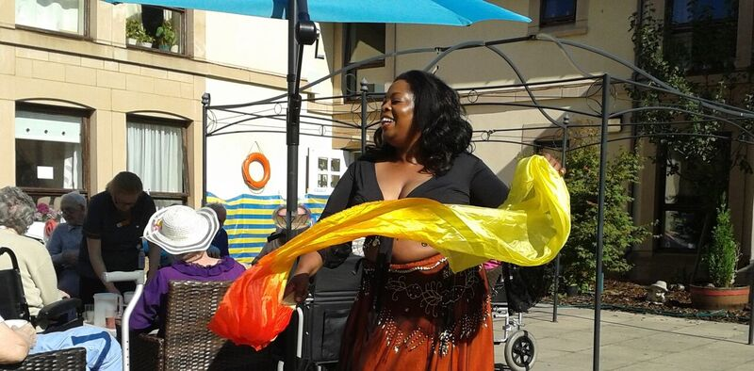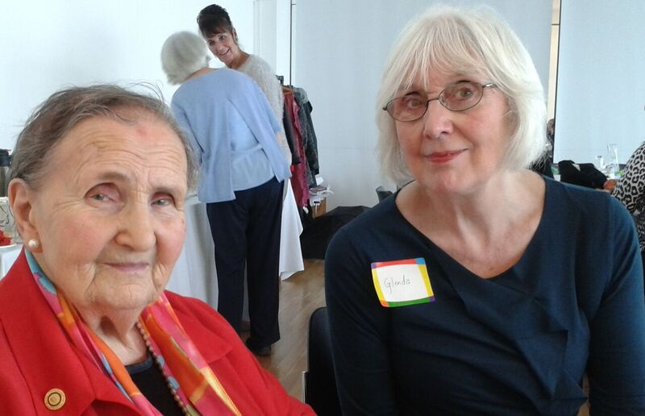
From visiting family to belly dancing, we know that older people should be able to do the things they love.
We’re Here Too brings together people who want to see more opportunities for older people who need more support, so they can participate in the issues and activities that interest them.
This year we will be having discussions around 3 themes at our events:
1. Building stronger links between people living in care homes and other supported settings and people in their local communities
2. Keeping active
3. What works for older people in BME communities.
Come along to the event that is convenient for you from 10am – 3.30pm. Tea, coffee, cake and lunch will be provided.
There is information on the programme for each event at www.otbds.org/projects/were-here-too/
Contact Outside the Box for or more information or to book your place.
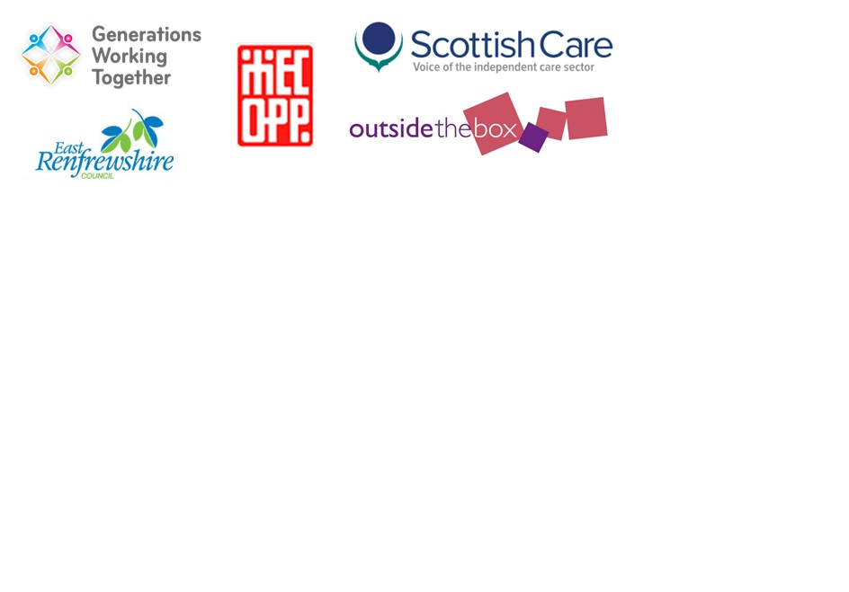
Email: alice@otbds.org or phone: 0141 419 0451
24th October
Eastwood House, East Renfrewshire

2nd December
Smithton Free Church,
Inverness

15th November
Forth Valley Sensory Centre, Falkirk

