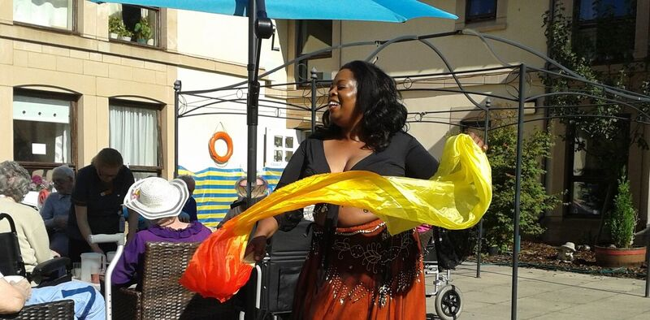
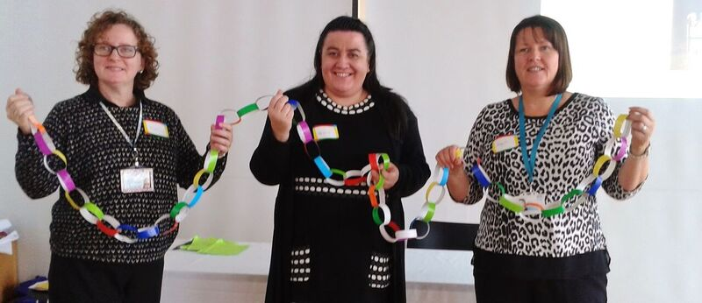
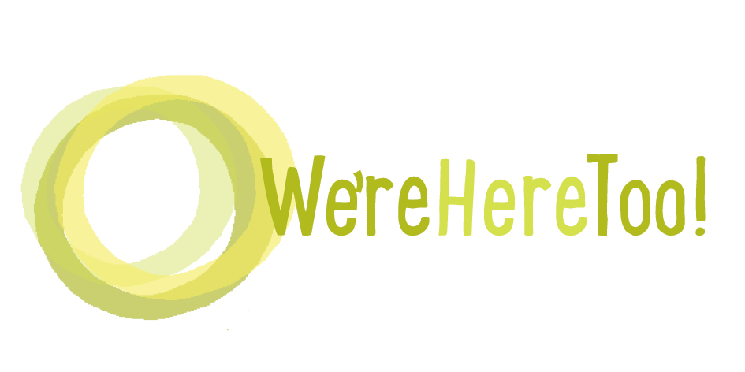
We’re Here Too

2nd December
Smithton Free Church,
Inverness

Information on public transport is on our website: http://otbds.org/projects/were-here-too/
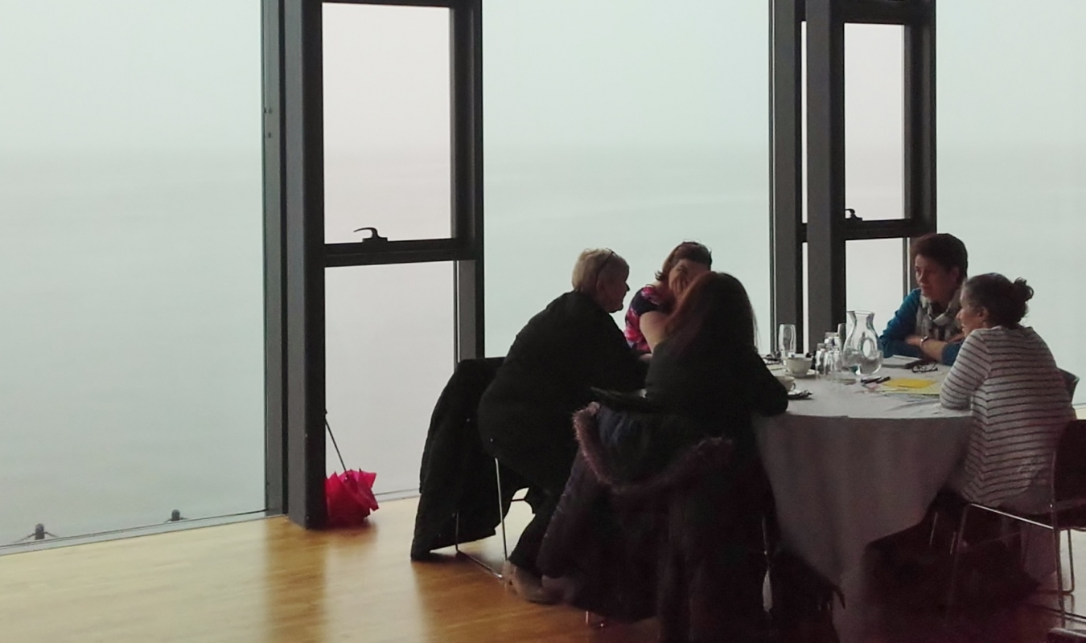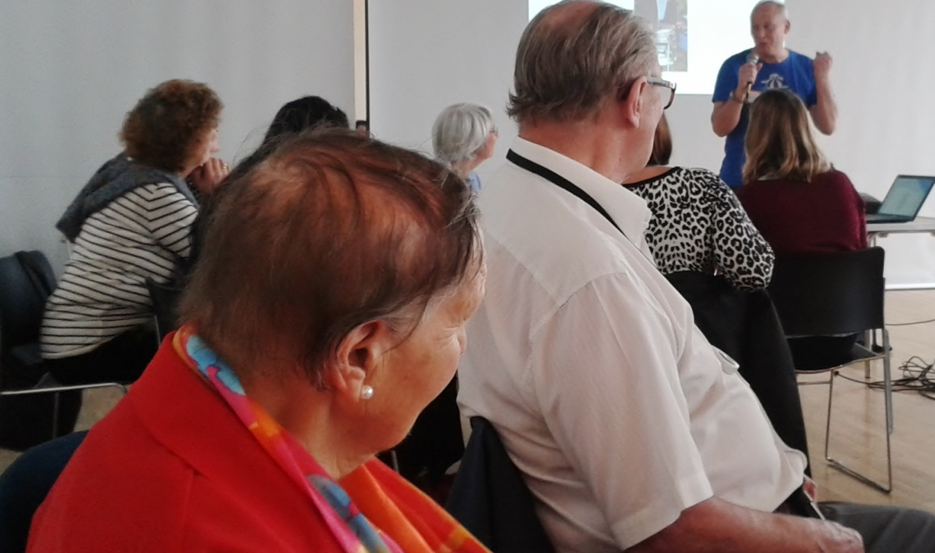
10 – 10.30: Coffee and registration

Morning session

Welcome and introduction

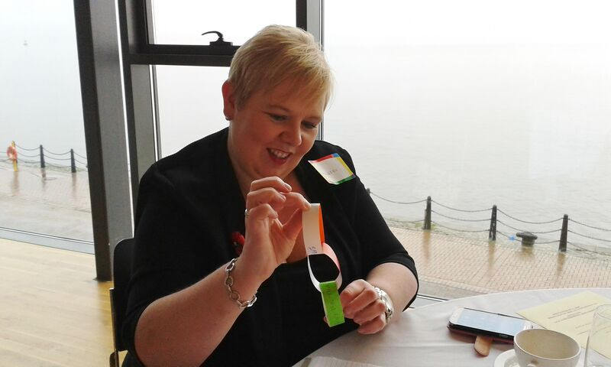
Support that is right for each person

- Examples of support for minority ethnic people and their families
- Inspection Volunteers – bringing lived experience into Care Inspectorate inspections

Being active - walks, belly dancing and more
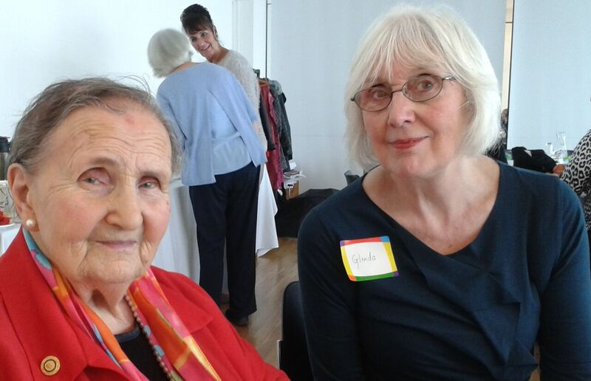
- Practical examples of how people are enabling people who need extra support to be more active

Discussion: What helps people who need extra support be part of their communities?

Lunch

Demonstration/practice of belly dancing for people who want to do this.
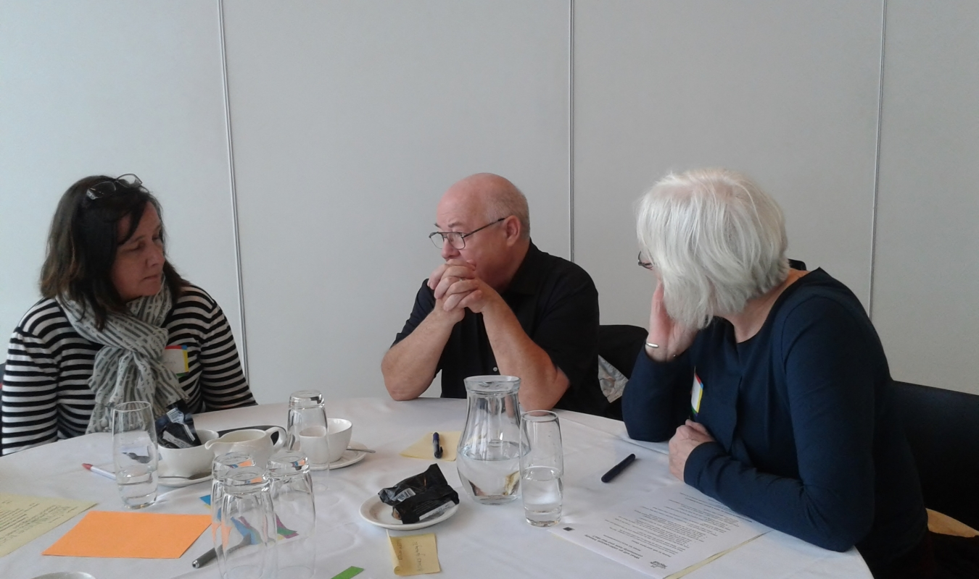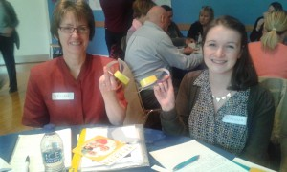

Afternoon session

New approaches to community-based support
- Examples from innovative projects
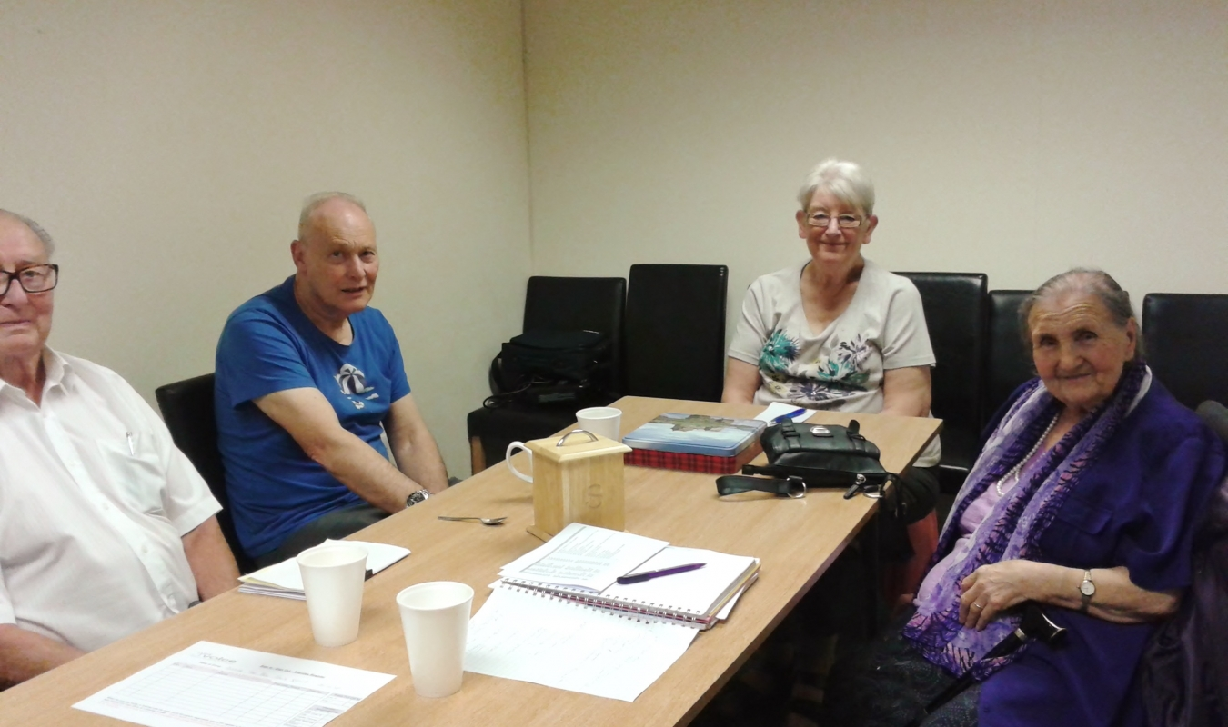
Discussion: What supports older people’s well-being?

Taking things forward

3.30: Home

